**The role of Intraspecific trait variation in driving Species Distributions and habitat associations of tree seedlings**

**A Thesis**

submitted to  
Indian Institute of Science Education and Research Pune in partial fulfilment of  
the requirements for the BS-MS Dual Degree Programme

by

Rajaditya Das



Indian Institute of Science Education and Research Pune  
Dr. Homi Bhabha Road, Pashan, Pune 411008, INDIA.

Oct, 2021

Supervisor: Dr. Meghna Krishnadas  
LaCONES, CSIR-CCMB, Hyderabad

All rights reserved

CERTIFICATE

This is to certify that this dissertation entitled ‘**The role of Intraspecific trait variation in driving Species Distributions and habitat associations of tree seedlings**’ towards the partial fulfilment of the BS-MS dual degree programme at the Indian Institute of Science Education and Research, Pune represents study/work carried out by Rajaditya Das under the supervision of Dr. Meghna Krishnadas, Senior Scientist, CSIR-CCMB during the academic year 2020-2021.



Rajaditya Das Dr. Meghna Krishnadas

(Student) (Research Guide)

Committee:

Research Guide: Dr. Meghna Krishnadas  
Expert Advisor : Dr. Sagar Pandit

This thesis is dedicated to my Dad

for driving me to school everyday for 14 years

DECLARATION

I hereby declare that the matter embodied in the report entitled ‘**The role of Intraspecific trait variation in driving Species Distributions and habitat associations of tree seedlings**’ are the results of the work carried out by me at the Laboratory for Conservation of Endangered Species, CCMB, Hyderabad under the supervision of Dr. Meghna Krishnadas and the same has not been submitted elsewhere for any other degree.



Rajaditya Das

30.10.2021

**TABLE OF CONTENTS**

| **CONTENT** | **Page No.** |
| --- | --- |
| Abstract | 6 |
| Acknowledgements | 7 |
| Chapter 1 Trait Based Ecology- A Literature Review | 8 |
| Chapter 2 Introduction | 10 |
| Chapter 3 Materials and Methods | 14 |
| Chapter 4 Results | 20 |
| Chapter 5 Discussion | 26 |
| Chapter 6 References | 29 |

| **Figure** | **Page No.** |
| --- | --- |
| Fig 2.1 | 11 |
| Fig 3.1 | 15 |
| Fig 4.1 | 20 |
| Fig 4.2 | 21 |
| Fig 4.3 | 23 |
| Fig 4.4 | 24 |

| **Table** | **Page No.** |
| --- | --- |
| Table 3.1 | 17 |
| Table 4.1 | 20 |
| Table 4.2 | 22 |
| Table 4.3.1 | 24 |
| Table 4.4 | 25 |
| Table 4.5 | 25 |

ABSTRACT

We are witnessing unprecedented levels of human induced alteration of forest ecosystems. To devise conservation efforts for fragmented forests, it is imperative to identify the mechanisms by which ecological processes maintain diversity and ecosystem functions. Environmental Filtering is a key process that influences species at the early life stages and determines future community composition. My study examines how the context in which environmental filtering occurs, in terms of intraspecific variation in traits and environmental heterogeneity, determines the final observed patterns in the community.

The study site, a 3600-ha landscape at Kadumane in the Western Ghats is a patchwork of tropical rainforest fragments separated by human structures and plantations. I sampled tree saplings from 149 (2mx2m) plots, across 6 forest fragments, and measured their leaf, stem, root and organismal traits along with the light (canopy openness photographs) and water (soil moisture sensor) conditions at each plot. My objectives were to (a) measure functional traits related to key organismal functions as per standard protocol; (b) quantify species-wise intraspecific trait variation(ISTV); (c) characterize niche width in terms of standard deviation, and functional positions as differences of species trait means from community trait mean; (d) relate the ISTV of species to their abundance, niche width and functional position through linear regression.

I show through this study that intraspecific variation in leaf traits such as Leaf Dry Matter Content and Leaf Mass Fraction is correlated with higher abundance and a wider environmental niche. ISTV in stem and root biomass allocation traits are correlated with lower niche widths and marginal functional positions in the community. Marginal functional position in Stem Mass fraction also correlates with a marginal niche position in the environment. These results together indicate that studying environmental filtering as just the interaction of the average phenotype of species with the mean environment is insufficient and the consideration of ISTV brings forth a more complete picture.

ACKNOWLEDGMENTS

This is to acknowledge the generous help of all those without whom this thesis could never have happened. First and foremost in guiding me throughout the project is my supervisor, Dr. Meghna Krishnadas. The past year has been the biggest learning experience in my life in large part thanks to Meghna. She has been a great mentor and a considerate friend through my highs and lows. She inspired me to pursue the joy of clear analytic thinking and the will to pursue science in the future.

I’m thankful to the companions I had at the field station during the four months of fieldwork- Lakshmi for being the captain at the helm of our field team, Saravanan for all his assistance in trait measurement. And Ranjana for being a delightful friend amidst the chaos of being a beginner in a field study. You made life better with your support at various points during analysis and otherwise. Ashok made working in the field easy and fun. Honorable mention to the Hero Splendor field bike I used everyday for never giving me any trouble.

My family have always been supportive and I always know in the back of my head that I am loved and for that I am very grateful. Rajesh is always a good friend in every season. I thank Anjan for being a friend who supports me in all lanes of life.

The time I spent at Hyderabad at LaCONES wouldn’t have been nearly as pleasant as it was without all the friends I made there. In particular Vinayak, Aditi, Lavanya and Ravi were very good friends and kept me alive with regular food and entertainment. I’m blessed to have met them. Thanks to Lavanya for helping me kickstart my work when I was in a rut. The lab members, in particular Rishhidh, Leela & Rahul were the best I could’ve asked for as lab mates. They were very helpful with suggestions and solutions during the entire project. I learnt a lot of ecology, presentation and banter skills from them over the course of a few dozen lab meets.

I’m very grateful to have met Shikari, the lovely cat, who made the worst days brighter.

I received much help from Harsha during multiple stages of the analysis and writing work. It really wouldn’t have been the same without her prompt responses to roadblocks I faced. Many thanks as well, to Charvee for helping me during the final stretch. Also thanks to Vyshnav, Akhil, Himanshu, Ayushman and Vaikunt for being real friends.

Zakhiya deserves a special mention for being a stable presence during the dozen crises I had over the course of the whole project. Your friendship is immensely valued and I know that your support was instinctive and needs no thanks.

I would also like to thank my expert advisor, Dr. Sagar Pandit, the academic office at IISER, the biology department and the thesis committee for constant encouragement and making adjustments to accommodate me when I was hindered by personal issues. IISER-Pune has been home to me while I have discovered myself, my dearest friends, the wide world and the wonders of science.

1

TRAIT-BASED ECOLOGY - A LITERATURE REVIEW

**1.1 Traits**

Functional trait-based ecology has heralded a way for ecologists to build up the dynamics involved in a community from a bottom-up perspective where the fundamental units of the system are functional traits([Adler et al. 2014](https://paperpile.com/c/W4kP9k/7CNa+Icjh+9TFV+HLhI+frVF+F46u+Dnk4+PwwV+a9fn+U5If+Fzz2)). Traits are clearly defined measurable organismal features of an individual. Functional traits are traits that are linked to a particular function such as water or light absorption, dispersal ability, heat resistance, reproduction, etc. Thus, functional traits serve as a quantifier of an individual’s relationships with the biotic and abiotic elements of its immediate environment. Since these functions that a trait is associated with determine the performance of individuals across various ecological interactions, trait-based ecology has shown promise in modelling community structure and dynamics ([Bruelheide et al. 2018](https://paperpile.com/c/W4kP9k/tBAT+8SMh+rEnn+HOMS+IKky+HIs1+TEmk+MgMe+KaC1+7IUv+LoG4+frkv+u6Ju+PTtC)).

The traits that have been typically measured in plants are extremely varied in terms of the level of the organismal structure they belong to. A trait could be an organismal trait, an organ system- level trait, an organ-level trait, or traits that cut across these levels such as chemical or physiological traits, phenological and life-history based traits. For example, plants have been characterized in terms of easily measurable traits like leaf area, leaf thickness, seed size and plant height that may be seen as superficial proxies in comparison to traits such as leaf C:N, xylem hydraulic, photosynthetic rate, stomatal density, etc. that are more explicitly related to plant functions. For the same function, say leaf transpiration ability, we could look at average leaf area as a soft proxy or stomatal density and conductance as a hard proxy. Based on this strength of relation between the trait and the function, traits can be categorized as ‘soft’ or ‘hard’ traits, and the effort/expense involved in their measurement generally increases as we move from softer to harder traits.

The advantage of trait-based descriptions of inferences in ecology is that we are able to make generalized statements and predictions. For example, the inference that species with X Specific Leaf Area are Y% likely to be found in an environment with high light is more useful than saying species A, B & C are found in high light environments, meaning that descriptive records of natural history can make way for quantitative records.

**1.2 Plant trait- environment relationships**

Furthermore, each trait is also coupled to other traits when they (a) are related to similar functions or life history strategies (seen in trait correlations in the leaf economic spectrum) or (b) are subject to biophysical/physiological constraints such as energy/nutrient investment limitations. Thus, relationships between different trait-abiotic factors and trait-trait pairs differ in direction and magnitude. These correlations also vary across species.

**1.3 Intraspecific variation in traits**

Trait variation arises from both phenotypic plasticity and genetic variation. Phenotypic plasticity causes trait variation in individuals of a species over time when faced with changes in the microclimatic conditions. This kind of variation is contingent on external changes. Genetic variation, on the other hand, manifests itself as trait variation internally, even if marginally subject to external influences upon gene expression. Variation in traits is present not only across species but within species as well.

Most trait-based studies of plant systems have used the mean trait value of a species as a singular measure of the species identity in ecological processes. Implicit in this, is the assumption that variation within species is insignificant compared to the variation across species for any trait. This has been challenged over the past decade with a plethora of studies [(Bolnick et al. 2011;](https://paperpile.com/c/W4kP9k/njy0) [Albert et al. 2011](https://paperpile.com/c/W4kP9k/ta6c); [)](https://paperpile.com/c/W4kP9k/njy0) finding Intraspecific trait variation to be comparable, or even greater with respect, to Interspecific trait variation among plant communities. The extent of variation is contingent on the scale, environment and the taxonomic composition of the system under observation.

The study of this variance partitioning in communities has provided insights in understanding community ecology by revealing an additional dimension along which species are linked with other species and their environment  [(Des Roches et al. 2017; Fajardo and Siefert 2019](https://paperpile.com/c/W4kP9k/7CNa+Icjh+9TFV+HLhI+frVF+F46u+Dnk4+PwwV+a9fn+U5If+Fzz2); [María Natalia Umaña and Swenson 2019](https://paperpile.com/c/W4kP9k/tBAT+8SMh+rEnn+HOMS+IKky+HIs1+TEmk+MgMe+KaC1+7IUv+LoG4+frkv+u6Ju+PTtC)).

2

INTRODUCTION

**2.1 Species Rarity & Commonness**

The natural world has a staggering diversity in life forms. Tropical forest landscapes are an epitome of this diversity. In the past, we have attempted to understand this biodiversity in terms of the number of species, distributions, interactions between species, etc. so as to infer the fundamental laws behind the curtains. In our quest to find universal laws in the chaos of ecosystems, one of the foremost findings has been that of species rarity and commonness. Very simplistically, most species are rare and a few species are common. This trend holds true to a large extent across scales, biomes and taxa. The ecological processes that link species amongst themselves and the environment around them, seamlessly overlapping and assembling the community are one of the core interests in the field of ecology(McGill et al. 2006).

Broadly speaking, the most prominent processes that drive species coexistence are dispersal limitation, environmental filtering and competitive exclusion (Nathan J. B. Kraft et al. 2015). Dispersal limitation determines whether a species is present or absent at a site as a consequence of the site being within dispersal range of a mature individual of that species. If a species is not limited by dispersal limitation and makes its way to a site, the environmental constraints of that site will act as a filter in species establishment. Further growth is dependent on the species in the immediate neighbourhood. Competitive exclusion may deter species persistence even if they are suited to the environment. The interplay of these processes brings about the observed species abundance distribution in a community.

Abiotic constraints upon an individual’s physiology are pronounced during the early life stage of a species. Since species exhibit high mortality during this stage, environmental filtering is key in determining species persistence and therefore future community composition.

Environmental filtering refers to the exclusion of some species from establishing in a location due to inability to tolerate the abiotic conditions at that location. It is usually visualized as a sieve made of abiotic constraints which only allow species with particular phenotypes to pass through and persist. As we’ve seen, functional traits are components of an individual’s phenotype, and they are optimized to conduct functions like resource acquisition, stress endurance and reproduction among others. In the case where there is a mismatch between the trait profile of a particular species and available environmental conditions, we expect the species to have reduced functionality along one or more organismal functions leading to growth reduction and mortality.

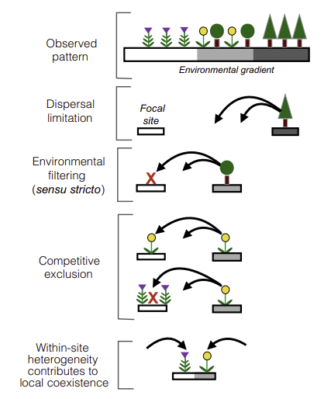

Fig. 2.1. Community assembly processes act together behind the scenes to create the observed patterns.

Taken from [Nathan J. B. Kraft et al. 2015]

Since environmental filtering allows individuals that are overall functionally compatible with the environment, individual traits cannot filter through a particular environmental gradient independently from other traits due to the various correlations amongst traits. Individual traits also undergo filtering coordinated across multiple environmental gradients with varying sensitivity to the different gradients. Thus, the optimum trait profile of a successful individual is a result of coordinated traits of an individual responding to multiple environmental gradients which can be visualized as a map from trait-hyperspace to environmental-hyperspace([Mi et al. 2021](https://paperpile.com/c/W4kP9k/7CNa+Icjh+9TFV+HLhI+frVF+F46u+Dnk4+PwwV+a9fn+U5If+Fzz2+ylCz)) .

How intraspecific trait variation (ISTV) may mediate plant abundance and distribution:  
If environmental filtering is a dominant process in a community, individuals with trait values which are optimum for the immediate local environment will be able to persist and proliferate. The species that are observed to be abundant in a community will then be composed of individuals that have ‘passed’ this filter, and are on average functionally better suited to the local abiotic conditions. How does environmental filtering function in the context of environmental heterogeneity and trait variation within and across species? This is the focus of my study.

**2.2 Hypothesis**

**H1)** In a homogenous environment, the filtering is similar across the entire community and therefore the differences between phenotypes of individuals of a successful species would be minimal and that of a rarer unsuccessful species would be higher.

Then, firstly we expect a negative correlation between the abundances and ISTVs of species, i.e species which have low ISTV are more abundant. Since we proposed that environmental filtering limits the success of highly variable and functionally incompatible species, we also expect the abiotic variation encompassed by the distribution of a species - its niche width, to be negatively correlated with its ISTV, suggesting that the species that have high variation amongst their individuals are present in a smaller subset of the environmental range available in the community.

To establish that the smaller environmental niche of some species is primarily due to their functional incompatibility to their environment, the species which exhibit high ISTV (and are rarer based on our earlier expectation) must have an extreme position in the functional space, i.e., the mean functional trait values of that species must be distant from the mean functional trait values of the community. Conversely, the more abundant, low ISTV, species must hold a core position in the functional space. The premise here is that the community weighted mean functional trait values represent the optima for the trait-environment interaction in the community of interest and distances from these optima indicate the level of functional incompatibility.

**H2)** When the environment is heterogeneous, filtering can happen at different parts of the available conditions. In this case, every individual’s ability to survive in a given part of the environmental gradient would depend on the local suitability of its trait value. Hence, species with higher ISTV may be better equipped to occupy and persist in a wider range of conditions than species with low ISTV. As a result, we expect species with higher ISTV to be more abundant and possess broader niches.

Again, the most successful species must have their mean phenotype optimised for the mean environment while also having high ISTV to maximise success in sites with environmental conditions belonging to both sides of the mean environment. Essentially, high ISTV species may be expected to occupy core position in the community functional space (low values of functional position).

Either of these combinations of signatures confirms the idea that while environmental filtering acts upon individuals to structure species abundance distributions, the context in terms of ISTV and environmental heterogeneity determine the final picture.

To test the hypotheses, I try to find the associations between the ISTV of species and their abundances, niche widths and functional positions. I sampled 1089 tree sapling individuals from 149 plots across 6 sites in a fragmented tropical rainforest. For each of the individuals, I collected 7 leaf,stem and root traits. I also collected light and water availability data at each plot. For a subset of this data, only considering 14 species with at least 5 individuals, I specifically asked:

1. What is the relation between abundance of a species and its intraspecific variation for a particular trait?  
2. Is the niche width of a species directly proportional to its intraspecific variation for a particular trait?  
3. Is the functional position of a species directly proportional to its intraspecific variation for a particular trait?

3

MATERIALS AND METHODS

**3.1 Study Site**

I conducted this study in Kadumane estate (12.924, 75.657) a human modified wet tropical forest in the Western Ghats Biodiversity Hotspot within the Kadumane village area. The site is spread over a 3600 ha area and has undergone long-term human modification while being administered as a tea estate. The average elevation of the site is 1044m and it receives rainfall to the tune of 6500mm annually. The landscape presently remains as a network of forest fragments separated by roads, small settlements, buildings/factories, grasslands and tea patches. The landscape is spatially heterogeneous in the amount of disturbance it has undergone: primarily through (a) logging (large scale as well as minor firewood collection); (b) road construction (tarmac, mud roads or forest pathways); c) tea/coffee farming; (d) construction of housing and factories; (e) and the ongoing Yettinahole Dam building effort. The fragments also differ in terms of the when they underwent the disturbance and the duration of it and their recovery period since. When transitioning outwards from the fragments, the edges offer sharp contrast in abiotic conditions as seen in instances where the edge is marked by tarmac roads or tea patches. Softer contrast is seen at edges with narrow/abandoned roads where the forest canopy is broken briefly.

**3.2 Sampling and Plot Design**

I spread my sampling effort of 149 plots across four locations: 46 plots at KDM( 12.90194°, 75.65867°), 37 plots at KT( 12.9125°, 75.6571°), 23 plots at DG(12.92378°, 75.65385°), 43 plots at VG(12.92925°, 75.65801°). These locations included forest fragments with relatively less human disturbance in recent times. I collected tree saplings (between 10 cm-50 cm) from each plot of 2m x 2m. I selected the plots in triplets starting from the fragment edge and moving inwards such that a matrix of 3 x N plots was formed after ‘N’ triplets or transects were sampled. This was done to get sufficient sampling across the edge-interior gradient. To avoid any local effects, I chose plots about 20-30 m away from each other such that the first transect of three plots was at 0-10m from edge, the next at 25-35m from edge and so on. I had to make some exceptions to the matrix format and the distance between plots due to difficult terrain or logistics. The plots were spread over 4 locations and 9 matrices. The matrices had about 5-6 transects on average, the minimum being 3 at matrices in VG and DG and the maximum was 15 at KDM. I covered diverse terrain (hill, valley, stream banks, rocky areas) and slopes while sampling, intending to maximise the range and variation of abiotic variables present across all the plots. All of the sampling was done in under four months from Nov, 2020 to Feb, 2021.

I focus on the sapling stage alone because the individuals that have reached this stage have already experienced environmental exclusion in terms of establishment. Past this stage, negative ecological interactions (whether from environmental filtering or from other biotic effects) largely present their effects as performance reduction as opposed to pre-sapling stages where they cause survival reduction.

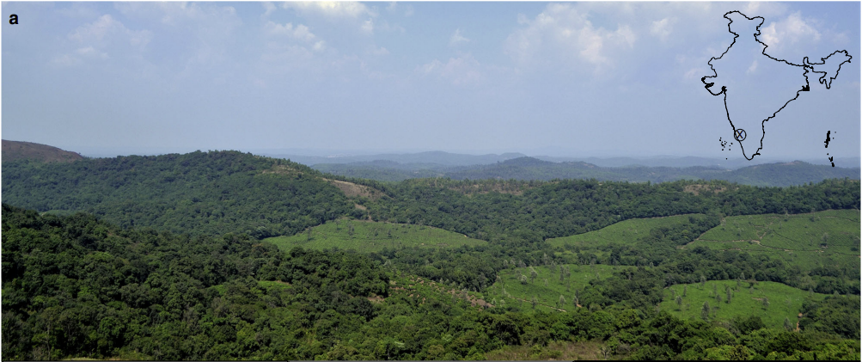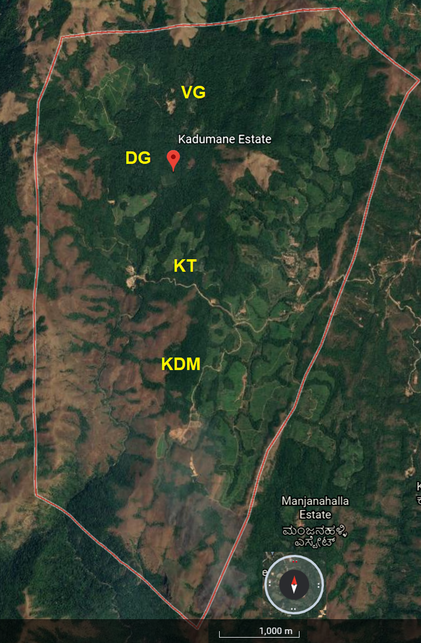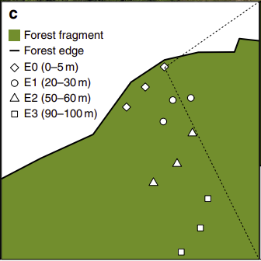

Fig 3.1. A. The fragmented landscape where I conducted the study situated in the western ghats biodiversity hotspot. B. The boundary of the Kadumane Estate and the four sites my plots were spread across. C. A schematic of my plot selection strategy from edge to interior in transects of 3.

Fig 3.1.A & C. taken from (Krishnadas, M. et al., 2018) . B. taken from google maps

**3.3 Trait Measurement**

I photographed the plant samples for species identification and subsequently measured the following from the fresh samples: leaf area index (through scans of healthy mature leaves), wet leaf mass, wet stem mass, stem length, wet root mass, root length and above ground plant mass. The samples were stored in paper bags for air drying at room temperature following which I oven dried them at 60°C for 72 Hrs to measure the dry masses of the leaves, stem and root in order to derive: specific leaf area (SLA), leaf dry matter content (LDMC), leaf mass fraction (LMF), stem mass fraction (SMF), specific stem length (SSL), root mass fraction (RMF).

| **Trait** | **Unit of Measurement** | **Formula** | **Physiological function** |
| --- | --- | --- | --- |
| **Specific leaf area**  **(SLA)** | **m2.kg−1 or mm2.mg−1** | **Specific leaf area is a ratio indicating how much leaf area a plant builds with a given amount of leaf biomass:**  **SLA=A/ML**  **where, A is the area of a given leaf or all leaves of a plant, and ML is the dry mass of those leaves** | **· SLA correlates positively with relative growth rate (RGR) and leaf net photosynthetic rate.**  **· It correlates negatively with leaf life span and palatability to herbivores.** |
| **Leaf dry matter content (LDMC)** | **g.g-1** | **LDMC = leaf dry mass / saturated fresh mass.** | **· LDMC strongly correlates with resource availability and relative growth rate.**  **· It is used to assess the plant strategy for resource acquisition and use.** |
| **Stem Specific Length (SSL)** | **m. g-1** | **SSL = stem length/stem dry mass** | **· This is a trait involved in biomass allocation, determining how much stem length is produced per unit of plant mass.** |
| **Root Specific Length (RSL)** | **m. g-1** | **RSL = root length/root dry mass** | **· Positively correlated to both root nitrogen concentration and root respiration**  **· Negatively correlated to root C:N and to root dry matter content.** |
| **Leaf Mass Fraction (LMF)** | **g.g-1** | **LMF = leaf dry mass/total plant dry mass** | **· This is the fraction of biomass allocated by the plant for the growth of the leaf.**  **· Decrease in light supply leads to an increase in the proportion of plant mass allocated to the leaves.** |
| **Root Mass Fraction (RMF)** | **g.g-1** | **RMF = root dry mass/total plant dry mass.** | **· This is the fraction of biomass allocated by the plant for the growth of the root.**  **· Increasing nutrient limitation generally drives increases in the length of root for a given unit of plant mass, due to an increase in the total plant mass allocated to the roots.** |
| **Stem Mass Fraction (SMF)** | **g.g-1** | **SMF = stem dry mass/total plant dry mass** | **· This is the fraction of biomass allocated by the plant for the growth of the stem.**  **· It is affected by the availability of resources and environmental conditions.** |

Table 3.1. An overview of the traits measured in this study.

## **3.4 Measurement of Environmental Variables**

**3.4.1 Light:**

I derived canopy openness as a proxy for the light available for absorption by the saplings at each plot. At each plot I captured hemispherical photographs of the canopy from the centre of the plot and a height of 0.5m above the ground. These images are extremely wide angled with a 180-degree field of view. The photographs were taken in the early mornings over the course of two weeks around mid- February, 2021. I captured photographs during overcast sky conditions to achieve an even background sans lens flare or glare. This enabled accurate canopy edge detection during estimation of canopy openness index. I used the Nikon Coolpix digital camera along with a fisheye lens for image capture.

To estimate the canopy openness index, I analysed the images using Gap Light Analyzer 2.0 software. This software has functionalities for estimating canopy structural parameters and the fraction of direct and diffuse light transmitted through the canopy gaps. The use of hemispherical images with this software has been a standard practice shown to have very good accuracy. For example, comparison between photosynthetically active radiation reaching the ground predicted by GLA and that measured by quantum sensors show a strong correlation (R2= 0.95, P < 0.0001).

**3.4.2 Water:**

Soil moisture availability was measured using a HydroSense II (handheld soil moisture sensor) with a CS659 12 cm probe. The device measures the volumetric water content in soil (θv)( the volume of liquid water per volume of soil).

At each plot, I measured the soil volumetric water content (%) in three-four different points such that each measurement was done in a different quadrant of the 2x2 m plot. This was done to average the variation in VWC within the plot. A minimum of three measurements are required to achieve a probability of 90% that the sample mean has a standard deviation of ±2.5 (lies within 5% error range).

The probe was inserted vertically, at least up to 10 cm at every plot and up to 12 cm at over 90% of the plots. To avoid moisture from condensation that is present in the mornings over the forest soil surface, I carried out the measurements close to noon (11am – 3pm). To avoid seasonal/weather based variation, all the measurements were done during a non-rainy week in mid-February, 2021.

**3.4.3 Leaf Area Index (LAI) measurement:**

I captured leaf scans for two mature leaves from each sample using a standard Epson scanner. I used the R package ‘LeafArea’ along with ImageJ software to derive leaf area index for each sample.

**3.5 Statistical Analyses**

I used the R software(R Core Team (2021)) to perform analyses on the data. I shortlisted 14 species for the analysis such that each of these species had a minimum of 5 individuals across all the plots sampled. This was a fair cut-off decided based on a trade-off between including enough species in the analysis while making sure each species had a decent number of individuals as sample points for calculating variation in trait values. Intraspecific Trait Variation(ISTV) was calculated for each trait for each species as the Coefficient of Variation(CV) of the trait values measured for the individuals of that species([María Natalia Umaña et al. 201](https://paperpile.com/c/W4kP9k/tBAT+8SMh+rEnn+HOMS+IKky+HIs1+TEmk+MgMe+KaC1+7IUv+LoG4+frkv+u6Ju+PTtC)5). The CV of data is defined as the standard deviation of the data divided by the mean of the data.

This measure was chosen over other statistics such as variance, standard deviation or mean/median because it is a relative measure of variability. This enables us to compare very different groups of data, as is the case in my study with different species, whose characteristics inherently belong to differing scales where absolute representations of variation may be misleading.  
  
Since there was considerable difference between the abundances of the shortlisted species, I used rarefaction to generate comparable estimates of variance in species traits. Therefore, to arrive at the ISTV of each trait, I randomly sampled 5 values from the sample space of each species-trait measurement and measured the CV pertaining to these values. I repeated this step algorithmically 999 times to saturate the overall mean CV into stable values along with confidence intervals. I defined the niche width of a species along each environmental axis of light and water as the range of the environmental measurements (canopy openness and soil moisture availability) corresponding to all the sampling plots that the individuals of that species were found at.

Functional position of a species is its mean position in the community trait space along different trait axes ([Mi et al. 2021](https://paperpile.com/c/W4kP9k/7CNa+Icjh+9TFV+HLhI+frVF+F46u+Dnk4+PwwV+a9fn+U5If+Fzz2+ylCz)). I derived the functional positions of each species by subtracting the mean trait value of each species from the mean trait value of the overall community and retaining the absolute value. For each question put forth in the introduction, I used linear regression to correlate abundance, niche width and functional position with intraspecific trait variation. The model used was the simplest form of linear regression, y = m + ax.

Niche position was defined similarly to functional position with the absolute difference between mean environmental measures of species and mean across all plots ([Mi et al. 2021](https://paperpile.com/c/W4kP9k/7CNa+Icjh+9TFV+HLhI+frVF+F46u+Dnk4+PwwV+a9fn+U5If+Fzz2+ylCz)).

4

RESULTS

**4.0. Analysis**

The sampling effort resulted in the collection of 1089 individuals across the 149 plots sampled in. These individuals belonged to over 45 species of which the 14 most abundant species were chosen for analysis. Most of the species had fewer than 5 individuals collected across the sampling area.

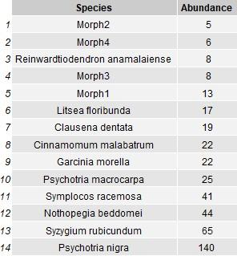

Table4.0.1. The species considered for the analysis and their total abundance across the sites.

4.1. Does ISTV drive abundances of species?

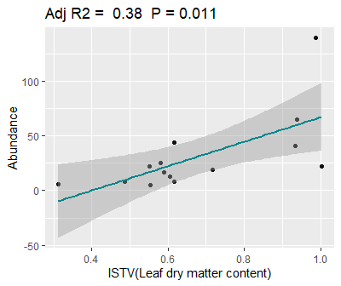

Figure 4.1. Relation between Intraspecific variation in Leaf dry mass content and abundance for each species.

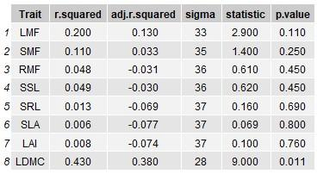

Table 4.1. Summary table with regression statistics for the model lm(Abundance ~ ISTV) that was run with the ISTV and abundance data for 14 species.

4.2. Is ISTV correlated with the functional position of a species in the community?

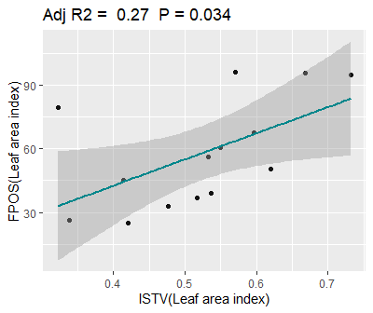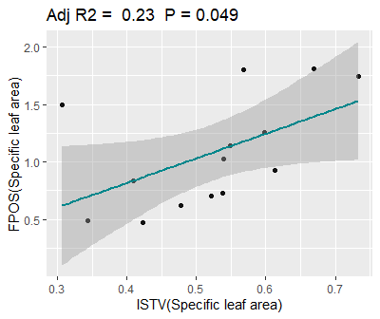

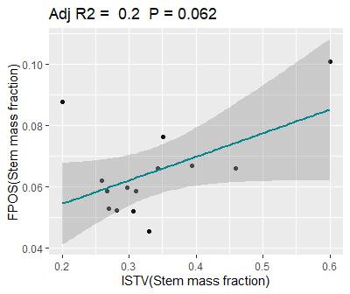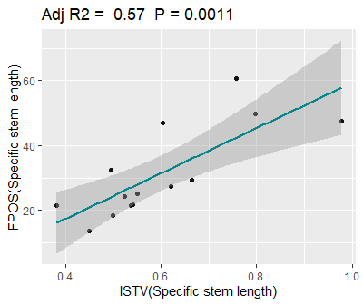

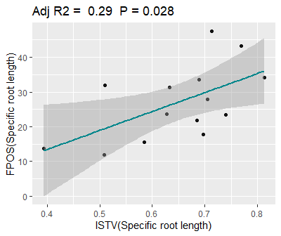

Figure 4.2. Relation between Intraspecific trait variation and functional positions for

1. LAI; b. SLA; c. SMF; d. SSL; e.SRL

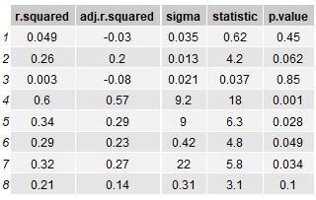

Table 4.2. Model = lm ( FPOS ~ ISTV).

4.3. Is ISTV correlated with the niche width of a species in the community?

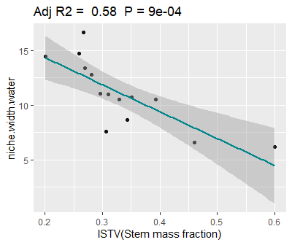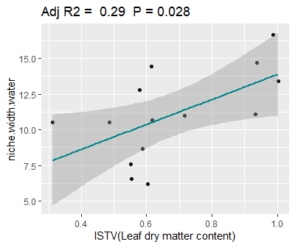

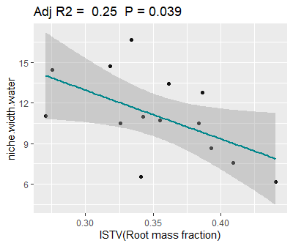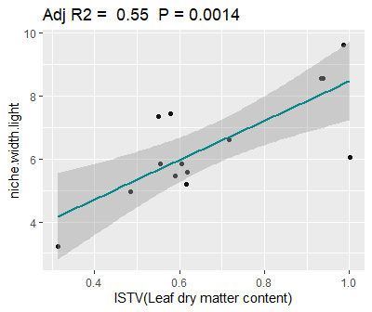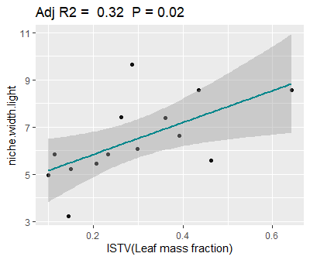

Figure 4.3. Relation between Intraspecific trait variation in SMF(a.); LDMC(b. and d.); RMF(c.); LMF(e.) and niche widths of species along Light(d. & e.) and Water (a. , b. and c.) gradients.

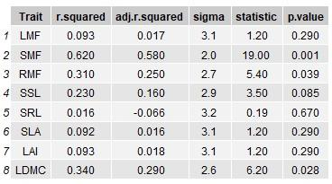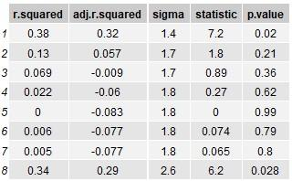

Table 4.3.1. Summary of the regressions, Model = lm ( Niche.width.light ~ ISTV); Table. 4.3.2. Model = lm ( Niche.width.water ~ ISTV) corresponding to the Fig 4.3.

Additionally, I looked for variables that correlate with the niche position (mean environmental condition a species is found at w.r.t the total environment) of species.

4.4. Is the functional position of a species related to its environmental niche position in a community?

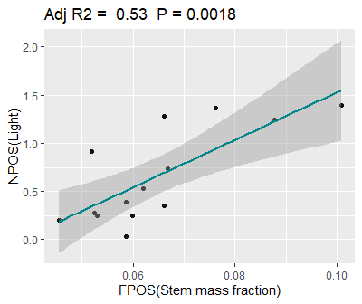

Figure 4.4. Relation between Functional position along SMF and Niche position of a species along the light gradient.

The only significant relationship between Niche position(Light) and Functional Position for all 8 traits was for the trait, Stem mass fraction.

4.5. Is Niche position correlated with ISTV in a community?

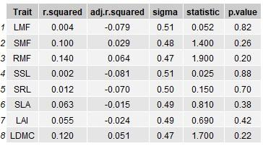

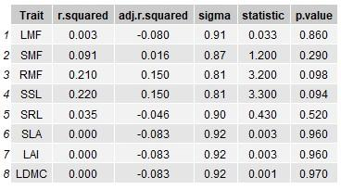

Table 4.4& 4.5. Niche. Pos. light/water ~ ISTV

All of the models for this question showed insignificant relationships.

5

DISCUSSION

**5.1 Interpretation**  
  
**Q1**. The only statistically significant regression shows that the abundance of a species is directly proportional to the amount of ISTV the species has in leaf dry mass content(LDMC). The positive relation is in keeping with our hypothesis for the relation of ISTV vs abundance in a heterogeneous environment. This means that species that have higher variation in LDMC are more successful across the landscape in this study. Species with higher variation in LDMC essentially have higher variation in their resource acquisition strategy and a nutrient allocation between leaf and stem/root organ systems. This may provide individuals with a better chance to pass the environmental filter in a highly variable environment.

**Q2**. There is a clear positive relation between ISTV in SMF, SRL, SSL, LAI, SLA and the corresponding functional position occupied by that species in the total functional space for that trait. Species that have a higher functional position, i.e., occupy a marginal position in the community functional space, have higher ISTV in all of these traits.

**Q3**. There is a strong positive correlation between ISTV (LDMC & LMF) and the niche width(light & water) of a species. This supports my hypothesis that higher ISTV will allow a species to survive in various environmental conditions and therefore such species will have a wider niche.

LDMC is a trait that is typically associated with the leaf economic spectrum of life strategies that ranges from conservative to acquisitive species. Variation in LDMC can enable a species to persist in both resource rich and resource poor areas. LDMC is related to both leaf net photosynthetic rate as well as stomatal density and is therefore determining the niche widths in both light and water gradients. LMF is associated with net growth rate which is representative of the life history strategy the plant uses.

There is a negative relation of ISTV( SMF & RMF) with niche width along soil water content. While this is contrary to our overall expectation for the niche~istv relationship, it might imply that the niche occupancy in terms of water availability is not improved by the presence of higher variability because the heterogeneity in terms of water is low in the landscape. Thai negative relation is then in keeping with my hypothesis for a homogenous water available landscape where an optimum trait profile with minimum variation is the best strategy to succeed. Therefore species with low variation in stem and root allocation traits (SMF & RMF) possess a wider niche.

**Q4**. This relationship shows the niche position with respect to the functional position of species. Species that are marginal in their functional position along SMF are also marginal in their niche occupancy in the light availability gradient. This adds to our interpretation of the IST ~ niche width for stem and root traits.

Niche position did not have any significant correlation with ISTV of species.

**5.2 Synthesis**

We see from Q1 that higher ISTV in leaf traits enables species to become more abundant in the environmental context of this study. We see that species who occupy core positions and therefore have mean trait values close to the environmental optima have higher variability in leaf traits. Thus, a winning strategy for a species in the face of environmental filtering across a heterogeneous landscape is to have the species mean trait value close to the community trait mean while also having a high amount of variation to succeed in the most amount of conditions in that landscape.

Functional position of species has a positive relationship with ISTV in SMF and RMF which means that species with higher variation occupy marginal positions in the community functional space which would limit them from being successful across the environmental gradients. Although this trend looks to upset our expectations for the relationship between functional position and ISTV. It instead tells us that core species mostly have stem and root traits that are closer to being invariant. In fact from the analysis for my first question, ISTV in SSL and RSL has no impact on the overall abundance of a species. One reason for this may be that the environmental filter isn’t strong along the soil water gradient. The landscape being a tropical wet forest, water might play less of a role in filtering than light which is highly variable in a dense forest. In such a scenario, both deviance from a general stem/root structure and high ISTV will render a species marginal in the community which is what we see here with a strong correlation between ISTV and functional position.

Niche width is directly proportional to the ISTV of a species and the strength of this trend suggests that the environment is indeed heterogeneous. If the environment was more uniform, ISTV would enable species to occupy slightly more environmental conditions than the mean since there would be very little variation from the mean environment in the first place.

**5.3** **Caveats and Next steps**

A common complaint with studies attributing species abundance gradients to environmental filtering is that many studies do not address confounding processes such as competitive exclusion or dispersal limitation that can also explain the absence of some species/individuals at a site. I have reasoned that the life stage I have studied is relatively less affected by these processes. Additionally, in an observational study, where it is not feasible to simply preclude biotic interactions, it is not possible to identify a single causal process with total certainty. In fact, in nature, there are always a multitude of interactions occurring at once and some relationships that are visible in experimental setups don’t translate into the field reality. The intention of this study was to identify if the interaction between environmental filtering and ISTV is a significant predictor of species distribution while in the midst of all the other interactions.

Does fragmentation of forests alter species distribution through ISTV mediated processes:  
Further studies can attempt to answer this question by building on this study. Alteration of forest structure due to human activity has myriad consequences upon the ecological processes that operate within a forest to maintain the dynamics of the forest. Forest fragmentation leads to the creation of an increased number of edges per unit area of forest. The processes that occur at these edges, edge effects, cause significant changes in the abiotic variables of the edge areas of the fragments, generally leading to drier and brighter conditions. Since the interior areas do not undergo an analogous environmental forcing, they must retain more abiotic variation than the edges. Therefore, we expect forest fragmentation and the ensuing edge effects to cause a positive gradient in abiotic variation as we move inwards from the edge, i.e., the interior areas are more heterogeneous than the edges.

Species occurring at the edges will then encounter a modified environmental filter as per the new environmental conditions. Our previous hypotheses indicate that the spatial heterogeneity, defined as the variation in abiotic conditions, of a community alters the way ISTV drives species abundance in that community. If fragmentation homogenizes the environmental conditions at the edges, we expect to see species abundant at the edges to have less ISTV than species abundant at the interiors. Otherwise, if the relationship between ISTV and abundance happens to be more strongly negative at the edges than the interior, meaning individuals of more abundant species exhibit little variation in their traits when found at the exterior compared to the individuals of the same species found at the interior.

6

REFERENCES

1. [Adler, Peter B., Roberto Salguero-Gómez, Aldo Compagnoni, Joanna S. Hsu, Jayanti Ray-Mukherjee, Cyril Mbeau-Ache, and Miguel Franco. 2014. “Functional Traits Explain Variation in Plant Life History Strategies.” *Proceedings of the National Academy of Sciences of the United States of America* 111 (2): 740–45.](http://paperpile.com/b/W4kP9k/a9fn)
2. Blonder, B., Lamanna, C., Violle, C. and Enquist, B.J. (2014), The n-dimensional hypervolume. Global Ecology and Biogeography, 23: 595-609. <https://doi.org/10.1111/geb.12146>
3. Fortunel, C., Valencia, R., Wright, S.J., Garwood, N.C. and Kraft, N.J.B. (2016), Functional trait differences influence neighbourhood interactions in a hyperdiverse Amazonian forest. Ecol Lett, 19: 1062-1070. <https://doi.org/10.1111/ele.12642>
4. Chitra-Tarak, R, Ruiz, L, Dattaraja, HS, et al. The roots of the drought: Hydrology and water uptake strategies mediate forest-wide demographic response to precipitation. *J Ecol*. 2018; 106: 1495– 1507. <https://doi.org/10.1111/1365-2745.12925>
5. Umaña, M.N., Zhang, C., Cao, M., Lin, L. and Swenson, N.G. (2017), A core-transient framework for trait-based community ecology: an example from a tropical tree seedling community. Ecol Lett, 20: 619-628. <https://doi.org/10.1111/ele.12760>
6. [Albert, Cécile H., Fabrice Grassein, Frank M. Schurr, Ghislain Vieilledent, and Cyrille Violle. 2011. “When and How Should Intraspecific Variability Be Considered in Trait-Based Plant Ecology?” *Perspectives in Plant Ecology, Evolution and Systematics*. https://doi.org/](http://paperpile.com/b/W4kP9k/ta6c)[10.1016/j.ppees.2011.04.003](http://dx.doi.org/10.1016/j.ppees.2011.04.003)[.](http://paperpile.com/b/W4kP9k/ta6c)
7. [Bello, Francesco de, Carlos P. Carmona, André T. C. Dias, Lars Götzenberger, Marco Moretti, and Matty P. Berg. 2021. *Handbook of Trait-Based Ecology: From Theory to R Tools*. Cambridge University Press.](http://paperpile.com/b/W4kP9k/7IUv)
8. [Bolnick, Daniel I., Priyanga Amarasekare, Márcio S. Araújo, Reinhard Bürger, Jonathan M. Levine, Mark Novak, Volker H. W. Rudolf, Sebastian J. Schreiber, Mark C. Urban, and David A. Vasseur. 2011. “Why Intraspecific Trait Variation Matters in Community Ecology.” *Trends in Ecology & Evolution* 26 (4): 183–92.](http://paperpile.com/b/W4kP9k/njy0)
9. [Brown, Alexandra M., David I. Warton, Nigel R. Andrew, Matthew Binns, Gerasimos Cassis, and Heloise Gibb. 2014. “The Fourth-Corner Solution - Using Predictive Models to Understand How Species Traits Interact with the Environment.” *Methods in Ecology and Evolution*. https://doi.org/](http://paperpile.com/b/W4kP9k/tDeM)[10.1111/2041-210x.12163](http://dx.doi.org/10.1111/2041-210x.12163)[.](http://paperpile.com/b/W4kP9k/tDeM)
10. [Bruelheide, Helge, Jürgen Dengler, Oliver Purschke, Jonathan Lenoir, Borja Jiménez-Alfaro, Stephan M. Hennekens, Zoltán Botta-Dukát, et al. 2018. “Global Trait-Environment Relationships of Plant Communities.” *Nature Ecology & Evolution* 2 (12): 1906–17.](http://paperpile.com/b/W4kP9k/MgMe)
11. [Chelli, S., G. Ottaviani, E. Simonetti, G. Campetella, C. Wellstein, S. Bartha, M. Cervellini, and R. Canullo. 2021. “Intraspecific Variability of Specific Leaf Area Fosters the Persistence of Understorey Specialists across a Light Availability Gradient.” *Plant Biology*  23 (1): 212–16.](http://paperpile.com/b/W4kP9k/5fEC)
12. [Cornelissen, J. H. C., S. Lavorel, E. Garnier, S. Díaz, N. Buchmann, D. E. Gurvich, P. B. Reich, et al. 2003. “A Handbook of Protocols for Standardised and Easy Measurement of Plant Functional Traits Worldwide.” *Australian Journal of Botany*. https://doi.org/](http://paperpile.com/b/W4kP9k/rEnn)[10.1071/bt02124](http://dx.doi.org/10.1071/bt02124)[.](http://paperpile.com/b/W4kP9k/rEnn)
13. [Des Roches, Simone, David M. Post, Nash E. Turley, Joseph K. Bailey, Andrew P. Hendry, Michael T. Kinnison, Jennifer A. Schweitzer, and Eric P. Palkovacs. 2017. “The Ecological Importance of Intraspecific Variation.” *Nature Ecology & Evolution* 2 (1): 57–64.](http://paperpile.com/b/W4kP9k/U5If)
14. [Díaz, Dilys M. Vela, Dilys M. Vela Díaz, Cecilia Blundo, Leslie Cayola, Alfredo F. Fuentes, Lucio R. Malizia, and Jonathan A. Myers. 2020. “Untangling the Importance of Niche Breadth and Niche Position as Drivers of Tree Species Abundance and Occupancy across Biogeographic Regions.” *Global Ecology and Biogeography*. https://doi.org/](http://paperpile.com/b/W4kP9k/I17A)[10.1111/geb.13139](http://dx.doi.org/10.1111/geb.13139)[.](http://paperpile.com/b/W4kP9k/I17A)
15. [Fajardo, Alex, and Andrew Siefert. 2018. “Intraspecific Trait Variation and the Leaf Economics Spectrum across Resource Gradients and Levels of Organization.” *Ecology* 99 (5): 1024–30.](http://paperpile.com/b/W4kP9k/HIs1)
16. [Fajardo, Alex, and Andrew Siefert. 2019. “The Interplay among Intraspecific Leaf Trait Variation, Niche Breadth and Species Abundance along Light and Soil Nutrient Gradients.” *Oikos*. https://doi.org/](http://paperpile.com/b/W4kP9k/Fzz2)[10.1111/oik.05849](http://dx.doi.org/10.1111/oik.05849)[.](http://paperpile.com/b/W4kP9k/Fzz2)
17. [Hubbell, Stephen P. 2005. “Neutral Theory in Community Ecology and the Hypothesis of Functional Equivalence.” *Functional Ecology*. https://doi.org/](http://paperpile.com/b/W4kP9k/frkv)[10.1111/j.0269-8463.2005.00965.x](http://dx.doi.org/10.1111/j.0269-8463.2005.00965.x)[.](http://paperpile.com/b/W4kP9k/frkv)
18. Jamil, T., Ozinga, W.A., Kleyer, M. and ter Braak, C.J. (2013), Selecting traits that explain species–environment relationships: a generalized linear mixed model approach. J Veg Sci, 24: 988-1000. <https://doi.org/10.1111/j.1654-1103.2012.12036.x>
19. Jose, Shibu & Gillespie, Andrew & George, Suman & Mohan Kumar, B.. (1996). Vegetation response along edge-to-interior gradients in a high altitude tropical forest in peninsular India. Forest Ecology and Management. 87. 51-62. 10.1016/S0378-1127(96)03836-4.
20. [Jucker, Tommaso, Tobias D. Jackson, Florian Zellweger, Tom Swinfield, Nichar Gregory, Joseph Williamson, Eleanor M. Slade, et al. 2020. “A Research Agenda for Microclimate Ecology in Human-Modified Tropical Forests.” *Frontiers in Forests and Global Change* 0. https://doi.org/](http://paperpile.com/b/W4kP9k/HLhI)[10.3389/ffgc.2019.00092](http://dx.doi.org/10.3389/ffgc.2019.00092)[.](http://paperpile.com/b/W4kP9k/HLhI)
21. [Kleyer, Michael, Juliane Trinogga, Miguel A. Cebrián-Piqueras, Anastasia Trenkamp, Camilla Fløjgaard, Rasmus Ejrnaes, Tjeerd J. Bouma, et al. 2019. “Trait Correlation Network Analysis Identifies Biomass Allocation Traits and Stem Specific Length as Hub Traits in Herbaceous Perennial Plants.” *Journal of Ecology*. https://doi.org/](http://paperpile.com/b/W4kP9k/HdJr)[10.1111/1365-2745.13066](http://dx.doi.org/10.1111/1365-2745.13066)[.](http://paperpile.com/b/W4kP9k/HdJr)
22. Krishnadas, M., Bagchi, R., Sridhara, S. *et al.* Weaker plant-enemy interactions decrease tree seedling diversity with edge-effects in a fragmented tropical forest. *Nat Commun* 9, 4523 (2018). <https://doi.org/10.1038/s41467-018-06997-2>
23. [Krishnadas, Meghna, Noelle G. Beckman, Juan Carlos Peñagos Zuluaga, Yan Zhu, James Whitacre, John W. Wenzel, Simon A. Queenborough, and Liza S. Comita. 2018. “Environment and Past Land Use Together Predict Functional Diversity in a Temperate Forest.” *Ecological Applications*. https://doi.org/](http://paperpile.com/b/W4kP9k/LoG4)[10.1002/eap.1802](http://dx.doi.org/10.1002/eap.1802)[.](http://paperpile.com/b/W4kP9k/LoG4)
24. [Kupers, Stefan J., Bettina M. J. Engelbrecht, Andrés Hernández, S. Joseph Wright, Christian Wirth, and Nadja Rüger. 2019. “Growth Responses to Soil Water Potential Indirectly Shape Local Species Distributions of Tropical Forest Seedlings.” *Journal of Ecology*. https://doi.org/](http://paperpile.com/b/W4kP9k/Icjh)[10.1111/1365-2745.13096](http://dx.doi.org/10.1111/1365-2745.13096)[.](http://paperpile.com/b/W4kP9k/Icjh)
25. [Kupers, Stefan J., Christian Wirth, Bettina M. J. Engelbrecht, Andrés Hernández, Richard Condit, S. Joseph Wright, and Nadja Rüger. 2019. “Performance of Tropical Forest Seedlings under Shade and Drought: An Interspecific Trade-off in Demographic Responses.” *Scientific Reports*. https://doi.org/](http://paperpile.com/b/W4kP9k/ylCz)[10.1038/s41598-019-55256-x](http://dx.doi.org/10.1038/s41598-019-55256-x)[.](http://paperpile.com/b/W4kP9k/ylCz)
26. [Laughlin, Daniel C., and David E. Laughlin. 2013. “Advances in Modeling Trait-Based Plant Community Assembly.” *Trends in Plant Science* 18 (10): 584–93.](http://paperpile.com/b/W4kP9k/SoaY)
27. [McGill, Brian J., Brian J. Enquist, Evan Weiher, and Mark Westoby. 2006. “Rebuilding Community Ecology from Functional Traits.” *Trends in Ecology & Evolution* 21 (4): 178–85.](http://paperpile.com/b/W4kP9k/8SMh)
28. Messier J, McGill BJ, Lechowicz MJ. How do traits vary across ecological scales? A case for trait-based ecology. Ecol Lett. 2010 Jul;13(7):838-48. doi: 10.1111/j.1461-0248.2010.01476.x. Epub 2010 May 12. PMID: 20482582.
29. [Mi, Xiangcheng, Zhenhua Sun, Yunfeng Song, Xiaojuan Liu, Jie Yang, Junjie Wu, Xiuqin Ci, et al. 2021. “Rare Tree Species Have Narrow Environmental but Not Functional Niches.” *Functional Ecology*. https://doi.org/](http://paperpile.com/b/W4kP9k/7CNa)[10.1111/1365-2435.13714](http://dx.doi.org/10.1111/1365-2435.13714)[.](http://paperpile.com/b/W4kP9k/7CNa)
30. Muscarella, Robert & Uriarte, María. (2016). Do community-weighted mean functional traits reflect optimal strategies?. Proceedings of the Royal Society B: Biological Sciences. 283. 20152434. 10.1098/rspb.2015.2434.
31. [Peres-Neto, Pedro R., Stéphane Dray, and Cajo J. F. ter Braak. 2017. “Linking Trait Variation to the Environment: Critical Issues with Community-Weighted Mean Correlation Resolved by the Fourth-Corner Approach.” *Ecography*. https://doi.org/](http://paperpile.com/b/W4kP9k/HOMS)[10.1111/ecog.02302](http://dx.doi.org/10.1111/ecog.02302)[.](http://paperpile.com/b/W4kP9k/HOMS)
32. Post, David & Bailey, Joseph & Roches, Simone & Hendry, Andrew & Kinnison, Michael & Palkovacs, Eric & Schweitzer, Jennifer & Turley, Nash & Vellend, Mark. (2012). The ecological importance of diversity within species.
33. [Pu, Xucai, María Natalia Umaña, and Guangze Jin. 2020. “Trait-Mediated Neighbor Effects on Plant Survival Depend on Life Stages and Stage-Specific Traits in a Temperate Forest.” *Forest Ecology and Management*. https://doi.org/](http://paperpile.com/b/W4kP9k/frVF)[10.1016/j.foreco.2020.118250](http://dx.doi.org/10.1016/j.foreco.2020.118250)[.](http://paperpile.com/b/W4kP9k/frVF)
34. [Riva, Enrique G. de la, Enrique G. de la Riva, Ignacio M. Pérez-Ramos, Ambra Tosto, Carmen M. Navarro-Fernández, Manuel Olmo, Teodoro Marañón, and Rafael Villar. 2016. “Disentangling the Relative Importance of Species Occurrence, Abundance and Intraspecific Variability in Community Assembly: A Trait-Based Approach at the Whole-Plant Level in Mediterranean Forests.” *Oikos*. https://doi.org/](http://paperpile.com/b/W4kP9k/IKky)[10.1111/oik.01875](http://dx.doi.org/10.1111/oik.01875)[.](http://paperpile.com/b/W4kP9k/IKky)
35. [Shen, Yong, Maria Natalia Umaña, Wenbin Li, Miao Fang, Yuxin Chen, Huanping Lu, and Shixiao Yu. 2019. “Coordination of Leaf, Stem and Root Traits in Determining Seedling Mortality in a Subtropical Forest.” *Forest Ecology and Management*. https://doi.org/](http://paperpile.com/b/W4kP9k/9TFV)[10.1016/j.foreco.2019.05.032](http://dx.doi.org/10.1016/j.foreco.2019.05.032)[.](http://paperpile.com/b/W4kP9k/9TFV)
36. [Shipley, Bill, Francesco De Bello, J. Hans C. Cornelissen, Etienne Laliberté, Daniel C. Laughlin, and Peter B. Reich. 2016. “Reinforcing Loose Foundation Stones in Trait-Based Plant Ecology.” *Oecologia* 180 (4): 923–31.](http://paperpile.com/b/W4kP9k/u6Ju)
37. [Siefert, Andrew, Cyrille Violle, Loïc Chalmandrier, Cécile H. Albert, Adrien Taudiere, Alex Fajardo, Lonnie W. Aarssen, et al. 2015. “A Global Meta-Analysis of the Relative Extent of Intraspecific Trait Variation in Plant Communities.” *Ecology Letters* 18 (12): 1406–19.](http://paperpile.com/b/W4kP9k/TEmk)
38. [Umaña, María Natalia, Gabriel Arellano, Nathan G. Swenson, and Jenny Zambrano. 2021. “Tree Seedling Trait Optimization and Growth in Response to Local-Scale Soil and Light Variability.” *Ecology* 102 (4): e03252.](http://paperpile.com/b/W4kP9k/Dnk4)
39. [Umaña, María Natalia, Min Cao, Luxiang Lin, Nathan G. Swenson, and Caicai Zhang. 2021. “Trade‐offs in Above‐ and Below‐ground Biomass Allocation Influencing Seedling Growth in a Tropical Forest.” *Journal of Ecology*. https://doi.org/](http://paperpile.com/b/W4kP9k/F46u)[10.1111/1365-2745.13543](http://dx.doi.org/10.1111/1365-2745.13543)[.](http://paperpile.com/b/W4kP9k/F46u)
40. Umaña, Maria & Zhang, Caicai & Cao, Min & Lin, Luxiang & Swenson, Nathan. (2015). Commonness, rarity, and intraspecific variation in traits and performance in tropical tree seedlings. Ecology Letters. 18. n/a-n/a. 10.1111/ele.12527.
41. [Umaña, María Natalia, and Nathan G. Swenson. 2019. “Intraspecific Variation in Traits and Tree Growth along an Elevational Gradient in a Subtropical Forest.” *Oecologia*. https://doi.org/](http://paperpile.com/b/W4kP9k/KaC1)[10.1007/s00442-019-04453-6](http://dx.doi.org/10.1007/s00442-019-04453-6)[.](http://paperpile.com/b/W4kP9k/KaC1)
42. [Umaña, María N., and Nathan G. Swenson. 2019. “Does Trait Variation within Broadly Distributed Species Mirror Patterns across Species? A Case Study in Puerto Rico.” *Ecology* 100 (8): e02745.](http://paperpile.com/b/W4kP9k/PTtC)
43. [Valladares, Fernando, and Ülo Niinemets. 2008. “Shade Tolerance, a Key Plant Feature of Complex Nature and Consequences,” October. https://doi.org/](http://paperpile.com/b/W4kP9k/tBAT)[10.1146/annurev.ecolsys.39.110707.173506](http://dx.doi.org/10.1146/annurev.ecolsys.39.110707.173506)[.](http://paperpile.com/b/W4kP9k/tBAT)
44. van der Sande, MT, Arets, EJMM, Peña-Claros, M, et al. Soil fertility and species traits, but not diversity, drive productivity and biomass stocks in a Guyanese tropical rainforest. Funct Ecol. 2018; 32: 461– 474. https://doi.org/10.1111/1365-2435.12968
45. [Worthy, Samantha J., Daniel C. Laughlin, Jenny Zambrano, María N. Umaña, Caicai Zhang, Luxiang Lin, Min Cao, and Nathan G. Swenson. 2020. “Alternative Designs and Tropical Tree Seedling Growth Performance Landscapes.” *Ecology* 101 (6): e03007.](http://paperpile.com/b/W4kP9k/PwwV)
46. [Worthy, Samantha J., and Nathan G. Swenson. 2019. “Functional Perspectives on Tropical Tree Demography and Forest Dynamics.” *Ecological Processes*. https://doi.org/](http://paperpile.com/b/W4kP9k/lYIy)[10.1186/s13717-018-0154-4](http://dx.doi.org/10.1186/s13717-018-0154-4)[.](http://paperpile.com/b/W4kP9k/lYIy)